Software Requirement Specifications

AI-Based Code Analyzer System



Submitted by
Muhammad Zain Arshad (S25BINFT7M04053)
Submitted to
Dr. Rana Nazir

Department of Information Technology
Faculty of Computing
The Islamia University of Bahawalpur

Meeting Details
Sr No | Details | Date | Supervisor Signature
1
2
3
4
5
6 | .
7
8
9
10
Summary
The AI-Based Code Analyzer System is a software application designed to evaluate the quality of programming code and assist developers in improving their coding practices. In modern software development, writing clean, efficient, and error-free code is essential, but many students and beginner programmers face difficulties in maintaining code quality and following standard coding practices. This system aims to provide an intelligent solution by combining static code analysis tools with basic machine learning techniques. It allows users to input source code, which is then analyzed to detect errors, bad coding practices, and potential issues. The system also generates a code quality score and provides suggestions for improvement. The main objective of this project is to develop a user-friendly platform that helps programmers understand their mistakes and improve their coding skills. The system is particularly useful for students, beginner developers, and anyone who wants to write better and more maintainable code.

Table of Contents
1. Introduction 5
1.1. Purpose 5
1.2. Scope 5
1.3. Product Perspective 6
1.4. User Characteristics 6
1.5. Similar apps and systems/Literature Review 7
1.6. Proposed Technologies 7
2. Requirements 8
2.1. Function Requirements 8
2.1.8. Suggestion Generation 11
2.2. Non-Functional Requirements 13
3. Use Cases and Flow of Processes 16
3.1. Use Case 1 16
4. References 19

- Introduction
In modern software development, writing clean, efficient, and maintainable code is very important. However, many students and beginner developers face difficulties in identifying errors, maintaining coding standards, and improving the overall quality of their code. Existing code analysis tools often provide technical feedback that is difficult for beginners to understand, or they only focus on basic rule checking without giving meaningful suggestions. The AI-Based Code Analyzer System is proposed to solve this problem by providing an intelligent and user-friendly platform that analyzes source code and gives clear feedback. The system uses static code analysis tools along with basic machine learning techniques to evaluate code quality, detect errors, and suggest improvements. The aim is to help users write better code and learn proper programming practices.
  - Purpose
The purpose of the AI-Based Code Analyzer System is to develop a software tool that can automatically analyze programming code and provide feedback regarding its quality. The system is designed to assist users in identifying coding errors, improving readability, and following standard coding practices. The main goals of the system are to generate a code quality score, highlight mistakes, and provide useful suggestions for improvement. This document describes the functional and non-functional requirements of the system and serves as a reference for developers, supervisors, and evaluators.
  - Scope
The scope of the AI-Based Code Analyzer System includes analyzing source code written in Python and providing feedback based on predefined rules and machine learning models. The system will allow users to input or upload their code and receive a detailed analysis report.
The system will:
- Detect syntax errors and code issues
- Evaluate code quality and readability
- Provide suggestions for improvement
- Generate a code quality score
- Classify code as Good, Average, or Poor
The system will not:
- Execute or compile the code
- Support multiple programming languages in the initial version
- Automatically fix code errors
  - Product Perspective
The AI-Based Code Analyzer System is a standalone application that operates independently. It is designed as a web-based system where users can access the platform through a browser without requiring complex installation.
The system integrates external tools such as code analyzers (e.g., Pylint or Flake8) and combines their output with machine learning techniques to provide intelligent feedback. It acts as a supportive tool rather than replacing existing development environments.
  - User Characteristics
The system is intended for the following types of users:
- Students: Beginner programmers who need help in improving coding skills and understanding errors
- Developers: Individuals who want to check and improve the quality of their code
- Instructors (optional): Teachers who want to evaluate student code
Users are expected to have basic knowledge of programming but do not need advanced technical expertise to use the system.
  - Similar apps and systems/Literature Review
There are several existing tools available for code analysis, such as Pylint and Flake8, which help detect errors and enforce coding standards. These tools are widely used in software development to maintain code quality. However, these tools have certain limitations:
- They provide technical messages that may be difficult for beginners to understand
- They do not provide intelligent suggestions based on learning models
- They lack a user-friendly interface for easy interaction
The proposed system aims to overcome these limitations by combining traditional analysis tools with machine learning to provide more meaningful and understandable feedback.
  - Proposed Technologies
The following technologies will be used to develop the system:
- Programming Language: Python
- Backend Framework: FastAPI or Django
- Frontend: HTML, CSS, JavaScript (or React)
- Machine Learning Library: Scikit-learn
- Code Analysis Tools: Pylint, Flake8
- Data Processing: Pandas and NumPy (optional)
These technologies are selected because they are easy to use, widely supported, and suitable for developing a machine learning-based application.

- Requirements
The AI-Based Code Analyzer System is designed to provide an automated solution for analyzing programming code and improving its quality. The system will accept user input in the form of source code or uploaded files and process it using static code analysis tools along with a machine learning model. The system will identify errors, detect bad coding practices, and evaluate the overall quality of the code. Based on the analysis, it will generate a score and provide suggestions for improvement. This section describes the functional and non-functional requirements of the system in detail.
  - Function Requirements
Authors will provide definite number of functional requirements in standard format. These requirements directly in the with functions which are already provided. The requirement format as following.
2.1.1 Code Input (Manual Entry)
- Name: FR001
- Purpose: Allow the user to manually enter or paste Python source code into the system for analysis. This feature helps users quickly test small code snippets without uploading files.
- Users: Student, Developer
- Input:
  - Python source code entered by the user
  - Code should not be empty
  - Code should follow basic syntax rules
  - Input field must accept multi-line code
- Output:
  - Code successfully received by system
  - Code stored temporarily for processing
  - Validation message (if input is invalid)
  - Code forwarded to preprocessing stage
2.1.2 Code File Upload
- Name: FR002
Purpose: Allow the user to upload a Python (.py) file for analysis, enabling full program evaluation.
Users: Student, Developer
- Input:
  - Python (.py) file
  - File must be valid format
  - File size must be within allowed limit
  - File should not be corrupted
- Output:
  - File uploaded successfully
  - Code extracted from uploaded file
  - File validation message (if invalid)
  - Code forwarded to preprocessing stage
2.1.3 Code Preprocessing
- Name: FR003
Purpose: Prepare and clean the code before analysis to ensure consistent and accurate results.
Users: System
- Input:
  - Raw code from manual entry or file upload
- Output:
  - Unnecessary spaces removed
  - Code formatted properly
  - Invalid characters handled
  - Clean code ready for analysis
2.1.4 Static Code Analysis
- Name: FR004
Purpose: Analyze the code using static analysis tools to identify syntax errors, warnings, and violations of coding standards.
Users: System
- Input:
  - Preprocessed code
- Output:
  - List of syntax errors
  - List of warnings
  - Detected bad coding practices
  - Detailed analysis report
2.1.5 Feature Extraction
- Name: FR005
Purpose: Extract important features from analysis results to be used for code quality evaluation and machine learning processing.
Users: System
- Input:
  - Analysis results (errors, warnings, metrics)
- Output:
  - Total number of errors
  - Total number of warnings
  - Code complexity level
  - Code length and structure details
  - Structured feature dataset
2.1.6 Code Quality Classification
- Name: FR006
Purpose: Classify the code into quality categories (Good, Average, Poor) using a machine learning model.
Users: System
- Input:
  - Extracted feature data
- Output:
  - Code classified as Good / Average / Poor
  - Classification result generated
  - Quality level prepared for display
2.1.7. Code Quality Score Generation
- Name: FR007
- Purpose: This function generates a numerical score that represents the overall quality of the code.
- User(s): System
- Input:
  - Analysis Data: Results and extracted features
- Output:
  - Code quality score (e.g., 1–10 scale)
  - Score reflects readability, errors, and structure

2.1.8. Suggestion Generation
- Name: FR008
- Purpose: This function provides meaningful suggestions to help users improve their code quality and follow best practices.
- User(s): System
- Input:
o Errors and warnings
o Detected issues
- Output:
o Suggestions for fixing errors
o Recommendations for better coding practices
o Improvement guidelines
2.1.9. Result Display
- Name: FR009
- Purpose: This function displays all analysis results in a user-friendly and understandable format.
- User(s): Student, Developer
- Input:
  - Analysis Output: Errors, score, classification, suggestions
- Output:
  - Display of detected errors
  - Display of code quality score
  - Display of classification result
  - Display of improvement suggestions
2.1.10. Error Handling
- Name: FR010
- Purpose: This function handles invalid inputs, system failures, and unexpected errors to ensure smooth operation.
- User(s): System
- Input:
  - Invalid code
  - Unsupported file format
  - System errors
- Output:
- Clear error messages shown to user
- Guidance to correct the issue
- System remains stable and does not crash
  - Non-Functional Requirements
This section defines the non-functional requirements of the AI-Based Code Analyzer System. These requirements describe the quality attributes, performance constraints, and operational characteristics that the system must satisfy. Non-functional requirements focus on how the system performs its functions rather than what functions it performs. They include aspects such as performance, usability, reliability, security, and scalability, ensuring that the system operates efficiently, securely, and effectively for its users.
2.2.1 Performance Requirement
- Name: NFR001
- Purpose: Ensure the system processes and analyzes code efficiently within acceptable time
- User(s): Student, Developer, System
- Input:
  - User code (manual input or uploaded file)
  - Multiple user requests
- Output:
  - Analysis results generated within 1–5 seconds
  - Fast system response
  - No delay during processing
2.2.2 Usability Requirement
- Name: NFR002
- Purpose: Ensure the system is easy to use and understandable for all users
- User(s): Student, Developer
- Input:
  - User interaction with system interface
  - Navigation actions
- Output:
  - Simple and user-friendly interface
  - Easy navigation
  - Clear and understandable results
2.2.3 Reliability Requirement
- Name: NFR003
- Purpose: Ensure the system provides consistent and accurate results
- User(s): System
- Input:
  - User code input
  - System processing requests
- Output:
  - Same input produces same result
  - Accurate analysis results
  - System does not crash during operation
2.2.4 Security Requirement
- Name: NFR004
- Purpose: Ensure protection of user data and secure handling of code
- User(s): System
- Input:
  - User code
  - Uploaded files
- Output:
  - Secure data handling
  - No unauthorized access
  - Code not shared with others
2.2.5 Scalability Requirement
- Name: NFR005
- Purpose: Ensure system can handle increased number of users and workload
- User(s): System
- Input:
  - Multiple user requests
  - Increased system load
- Output:
  - Stable performance under load
  - System supports multiple users
  - No major performance drop
2.2.6 Maintainability Requirement
- Name: NFR006
Purpose: Ensure system is easy to maintain and update
- User(s): Developer
- Input:
  - System updates
  - Code modifications
- Output:
  - Easy system updates
  - Quick bug fixing
  - Easy addition of new features

- Use Cases and Flow of Processes
Use cases are the formal representation of process flow defined by functional requirements. Authors should provide a flow of events in this. There should be system level use case which is directly influenced to project functions with their user(s) (called actor(s)) which are described in requirements chapters
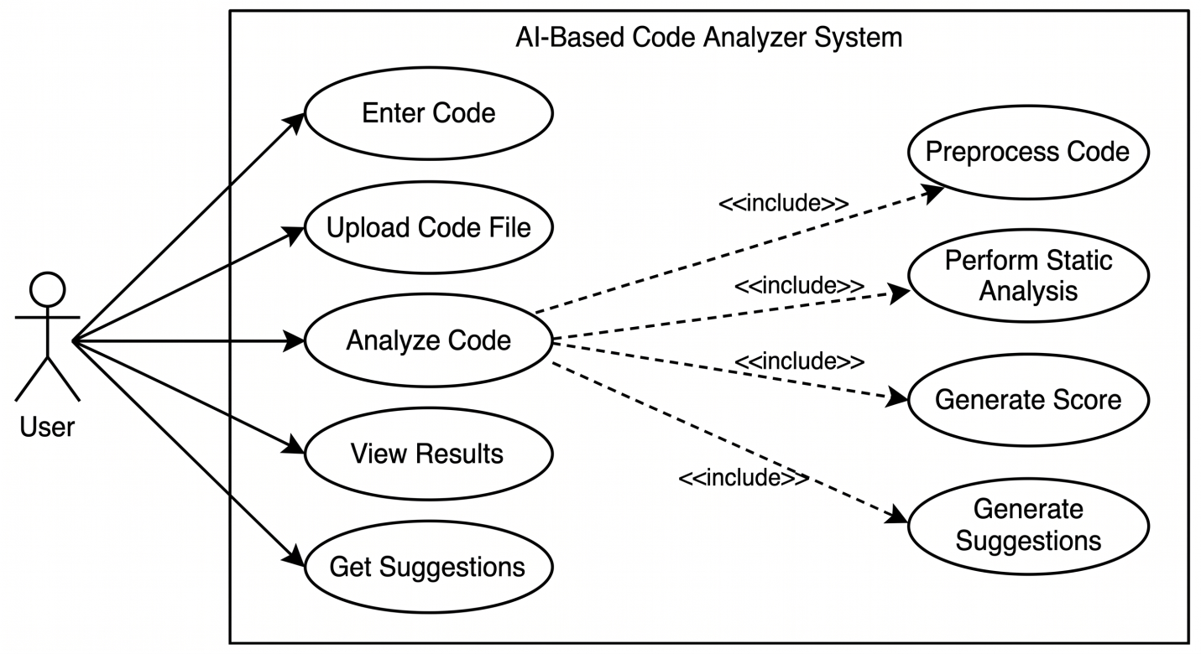
Figure 1: System Level Use Case Diagram

  - Use Case 1
Table 1:UC001 – Enter Code
Field | Details
ID | UC001
Name | Enter Code
Description | This use case describes the process of manually entering or pasting Python code into the system for analysis.
Requirement(s) | FR001
Actor(s) | User
Precondition | User has access to the system and input interface is available
Postcondition | Code is stored temporarily and ready for analysis
Basic Flow | 1. User opens system  2. User enters or pastes Python code  3. System validates code input  3.1 Check code is not empty  3.2 Validate basic syntax structure  4. System accepts code
Alternative Flow | 1. User clears input field  2. Re-enters code
Exceptions | 1. Empty input  2. Invalid code format
ID | UC001
Name | Sign Up
Description | This use case describes the process flow of Sing Up
Requirement(s) | FR001
Actor(s) | Admin, Data Entry, Operator
Precondition | Actors must not be member of Hospital
Postcondition | Actors will view the message for approval from admin
Table 2: Upload Code
Field | Details
ID | UC002
Name | Upload Code File
Description | This use case describes the process of uploading a Python file for analysis.
Requirement(s) | FR002
Actor(s) | User
Precondition | User has valid Python (.py) file
Postcondition | File uploaded and code extracted successfully
Basic Flow | 1. User selects upload option  2. User chooses Python file  3. System validates file type  3.1 Check file extension  3.2 Check file size  4. System uploads file  5. Code extracted
Alternative Flow | 1. User selects another file
Exceptions | 1. Invalid file format 2. File upload failed
Table 3: Analyze Code
Field | Details
ID | UC003
Name | Analyze Code
Description | This use case describes the process of analyzing code and generating results.
Requirement(s) | FR004, FR005, FR006, FR007, FR008
Actor(s) | User
Precondition | Code is available in system
Postcondition | Analysis completed and results generated
Basic Flow | 1. User clicks Analyze Code  2. System preprocesses code  3. System performs static analysis  4. System extracts features  5. System classifies code quality  6. System generates score  7. System generates suggestions
Alternative Flow | 1. User uploads new code and restarts analysis
Exceptions | 1. Invalid code  2. Analysis failure
Table 4: View Results
Field | Details
ID | UC004
Name | View Results
Description | This use case describes the process of viewing analysis results.
Requirement(s) | FR009
Actor(s) | User
Precondition | Analysis completed successfully
Postcondition | Results displayed to user
Basic Flow | 1. User selects View Results  2. System retrieves results  3. System displays errors  4. System displays score  5. System displays classification
Alternative Flow | 1. User refreshes results page
Exceptions | 1. No results available
Table 5: Get Suggestions
Field | Details
ID | UC005
Name | Get Suggestions
Description | This use case describes the process of retrieving code improvement suggestions.
Requirement(s) | FR008
Actor(s) | User
Precondition | Analysis completed
Postcondition | Suggestions displayed successfully
Basic Flow | 1. User selects Get Suggestions  2. System retrieves recommendations  3. System displays suggestions
Alternative Flow | 1. User requests suggestions again
Exceptions | 1. No suggestions available
- References
[1] I. Sommerville, Software Engineering, 10th ed. Boston, MA, USA: Pearson, 2015.
[2] T. H. Cormen, C. E. Leiserson, R. L. Rivest, and C. Stein, Introduction to Algorithms, 3rd ed. Cambridge, MA, USA: MIT Press, 2009.
[3] S. Raschka and V. Mirjalili, Python Machine Learning, 3rd ed. Birmingham, U.K.: Packt Publishing, 2019.
[4] A. Géron, Hands-On Machine Learning with Scikit-Learn, Keras, and TensorFlow, 2nd ed. Sebastopol, CA, USA: O’Reilly Media, 2019.
[5] Python Software Foundation, “Python Documentation,” 2025. [Online]. Available: https://www.python.org/doc/
[6] Pylint Development Team, “Pylint Documentation,” 2025. [Online]. Available: https://pylint.pycqa.org/
[7] Flake8 Development Team, “Flake8 Documentation,” 2025. [Online]. Available: https://flake8.pycqa.org/
[8] Scikit-learn Developers, “Scikit-learn Documentation,” 2025. [Online]. Available: https://scikit-learn.org/

